HW 5

Refer to Tutorial 4: Graphic Design with CSS

Complete Session 4.3 pages HTML 328 to HTML 346

1. Add a screenshot of the **tb_komatsu.html** file displayed in a browser after completing Step 3 on page HTML 346. Include the browser address bar.

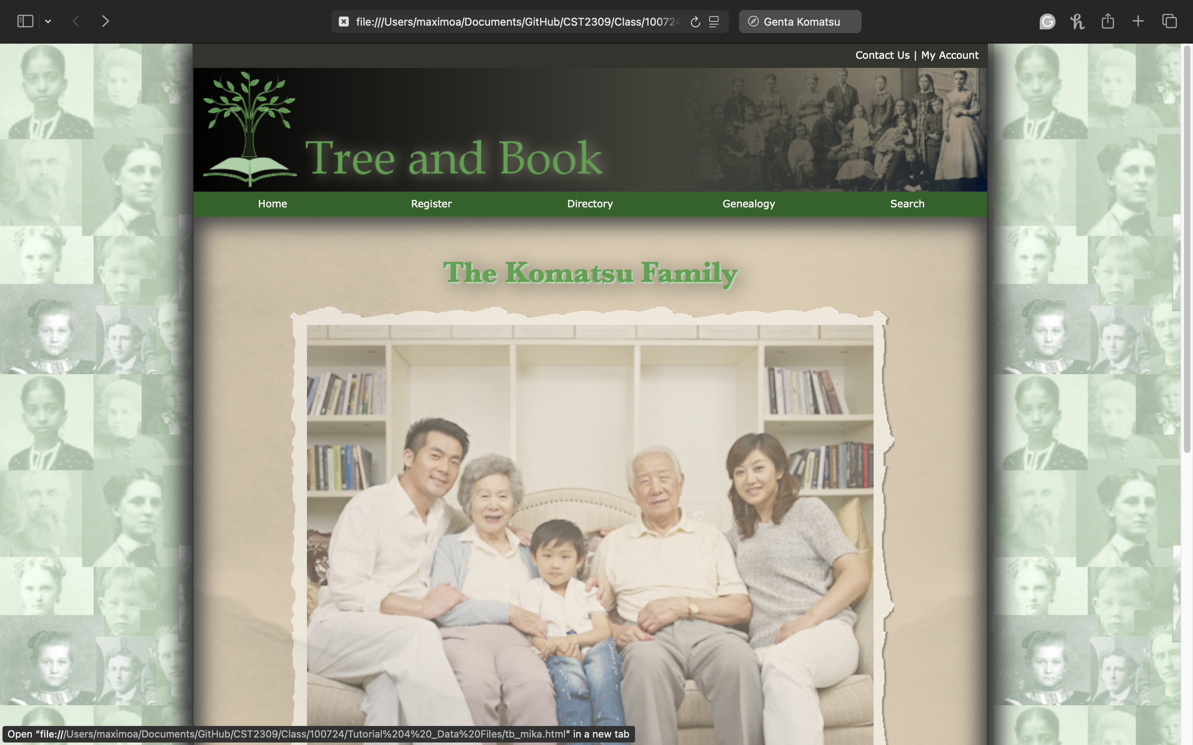

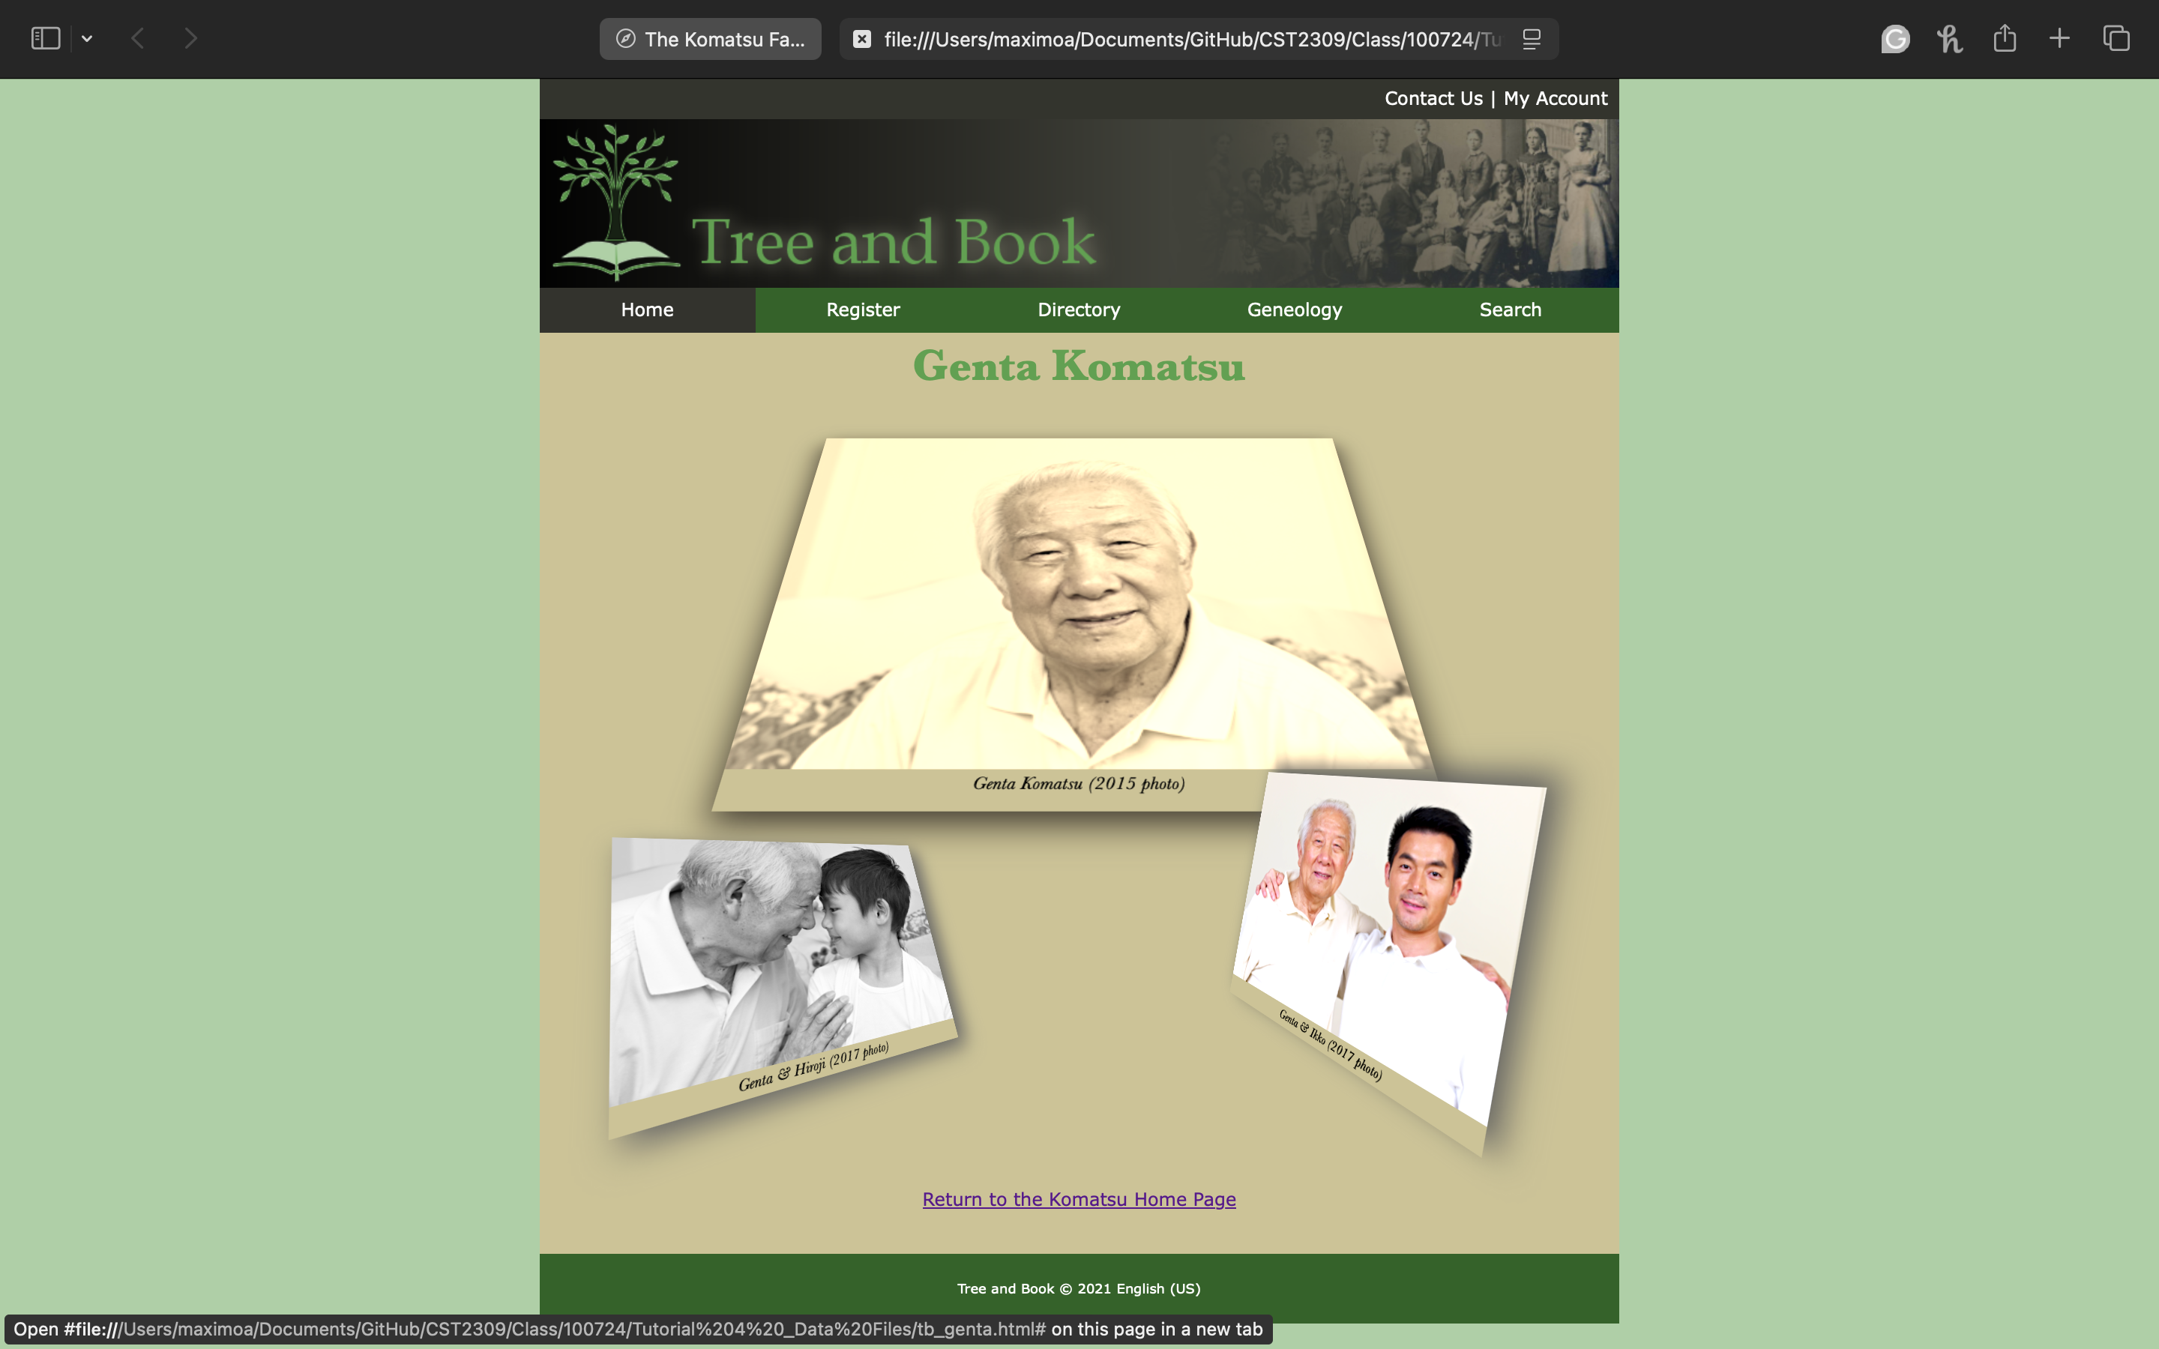

1. Complete the Session 4.3 Quick Check